Student: | Test
Date: 2 May 2004

Questions:

- Design Requirements (6 marks)
- Explain the requirements for materials for reactor coolant and moderator, list the usual materials and discuss how they meet the requirements. (50%)
- Explain how the type of the reactor influences the selection of the moderator and coolant material. (50%)

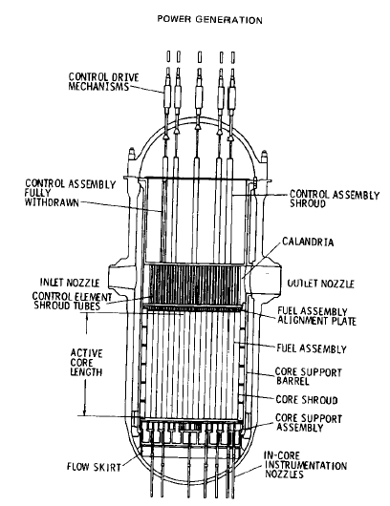
- Power Reactor Types (6 marks)
For the reactor shown in the figure below explain:
- Draw a primary coolant flow diagram and explain the flow path. (30%)
- Explain the configuration of the core and fuel assemblies. (30%)
- List the most important difference compared to a CANDU reactor. (40%)

- Process Design Evolution (5 marks)
- Explain the main direction in CANDU process design evolution. (50%)
- Capture the most important changes to the ACR-700 design as compared to the traditional CANDU. (50%)

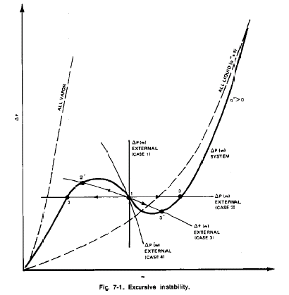
- Flow Instabilities (5 marks)
For the flow instability diagram shown in the figure below:
  - Explain the instability criterion. (30%)
  - Discuss the effect of channel heat transfer to the instability curve. (30%)
  - Discuss the importance in case of flow diversion in a loop with two parallel non-equal channels. (40%)

- Thermal Efficiency (6 marks)
- Define the thermal efficiency of a NPP and explain the factors of influence. (50%)
- Explain the methods (design options) to increase NPP thermal efficiency, and discuss feasibility and importance of each option. (50%)

- Steam Generator Calculations (6 marks)
  - Explain the principles of the design of the steam generator (40%)
  - Explain the behavior of the steam generator using the heat duty diagram (60%)

- Fuel-Coolant Heat Transfer (6 marks)
  - Draw a diagram of temperature distribution across the fuel element and coolant in radial direction, and explain the change of rate of heat transfer across different components (50%)
  - Draw a diagram of temperature distribution along the fuel element and coolant in axial direction and explain the change of rate of heat transfer along different components (50%)

- Two-phase Flow (5 marks)
- Identify all boiling heat-transfer modes and transition points in the boiling curve. (40%)
- State all possible boiling heat-transfer modes encountered in a heat-flux-controlled system with increasing heat flux from single-phase liquid flow at the same local flow conditions (i.e., pressure, mass flux and quality). (25%)
- State all possible boiling heat-transfer modes encountered in a temperature-controlled system with increasing wall temperature from single-phase liquid flow at the same local flow conditions (i.e., pressure, mass flux and quality). (35%)

- Film Boiling (5 marks)
- Identify heat-transfer modes (i.e., conduction, convection, and radiation) between the heated wall and two phases in dispersed-flow film boiling. (40%)
- Provide the direction of heat flow at each solid line. (20%)
- What does the dashed line represent? (40%)

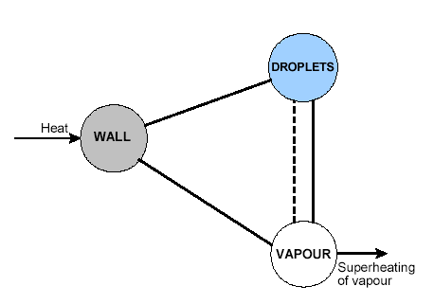

- Pressure Drop (7 marks)
- Identify all pressure-drop components with flow over a string of heated 37-element bundles inside a horizontal pressure tube. (20%)
- Arrange thermodynamic qualities for the following transition points in ascending order: (20%)
  - Onset of annular flow
  - Onset of nucleate boiling
  - Onset of significant void
  - Saturation liquid point
  - Saturation vapour point

- Calculate the two-phase pressure drop for light-water flow over the 37-element bundle (element outside diameter of 13.06 mm) inside a pressure tube (inside diameter of 103.86 mm) (60%)
Pressure: 9 MPa
Mass flow rate: 17 kg/s
Mass quality: 0.2
Flow area: 3515 mm²
Bundle loss coefficient: 1.7
Saturated liquid density: 704.7 kg/m³
Saturated vapour density: 48.8 kg/m³
Two-phase multiplier, φ²_{LO} = (1 + x (ρ_{f} / ρ_{g} - 1))

- CHF (7 marks)
- Evaluate the critical heat flux, using the attached CHF table, for the 37-element bundle (element outside diameter of 13.06 mm) inside a pressure tube (inside diameter of 103.86 mm) at the pressure of 9.5 MPa, mass flow rate of 17 kg/s and thermodynamic quality of 20%. (50%)
- Evaluate the critical heat flux for the bundle inside a pressure tube with 5% diametral creep (i.e., pressure-tube inside diameter is 5% larger) at the same flow conditions. (25%)
- Identify the boiling heat-transfer modes for these two cases if the local heat flux is 1500 kW/m². (25%)

Pressure (kPa) | Mass Flux (kg.m⁻².s⁻¹) | Quality
Pressure (kPa) | Mass Flux (kg.m⁻².s⁻¹) | _0.5 | _0.4 | _0.3 | _0.2 | _0.15 | _0.1 | _0.05 | 0 | 0.05 | 0.1 | 0.15 | 0.2 | 0.25 | 0.3 | 0.35 | 0.4 | 0.45 | 0.5 | 0.6 | 0.7 | 0.8 | 0.9 | 1
9000 | 0 | 4836 | 4571 | 4301 | 4034 | 3902 | 3783 | 3639 | 3352 | 2503 | 1977 | 1637 | 1290 | 1179 | 992 | 843 | 739 | 660 | 608 | 560 | 471 | 431 | 349 | 0
9000 | 50 | 5422 | 5114 | 4813 | 4547 | 4432 | 4335 | 4213 | 3960 | 3071 | 2528 | 2304 | 2110 | 1945 | 1810 | 1699 | 1610 | 1536 | 1457 | 1152 | 971 | 938 | 650 | 0
9000 | 100 | 5916 | 5571 | 5251 | 4988 | 4892 | 4811 | 4704 | 4462 | 3658 | 3134 | 2976 | 2841 | 2697 | 2575 | 2458 | 2373 | 2317 | 2165 | 1554 | 1306 | 1300 | 1040 | 0
9000 | 300 | 6366 | 5916 | 5527 | 5300 | 5260 | 5239 | 5236 | 5194 | 4944 | 4270 | 3692 | 3478 | 3344 | 3257 | 3065 | 2894 | 2713 | 2334 | 1672 | 1380 | 1197 | 899 | 0
9000 | 500 | 6641 | 6100 | 5668 | 5412 | 5332 | 5205 | 5147 | 5114 | 4925 | 4243 | 3625 | 3364 | 3160 | 2999 | 2887 | 2741 | 2351 | 1983 | 1583 | 1282 | 904 | 626 | 0
9000 | 1000 | 7221 | 6432 | 5947 | 5625 | 5398 | 4936 | 4705 | 4703 | 4697 | 4204 | 3520 | 3118 | 2854 | 2661 | 2545 | 2118 | 1553 | 1143 | 984 | 729 | 346 | 311 | 0
9000 | 1500 | 7976 | 7023 | 6356 | 5856 | 5535 | 4958 | 4693 | 4467 | 4189 | 3730 | 3227 | 2850 | 2712 | 2495 | 2034 | 1429 | 1081 | 892 | 546 | 350 | 131 | 119 | 0
9000 | 2000 | 9111 | 8171 | 7160 | 6258 | 5863 | 5299 | 4835 | 4196 | 3569 | 3097 | 2746 | 2448 | 2312 | 1931 | 1428 | 1027 | 745 | 603 | 345 | 186 | 97 | 48 | 0
9000 | 2500 | 10108 | 9252 | 8185 | 7162 | 6749 | 6025 | 5004 | 4119 | 3339 | 2797 | 2521 | 2241 | 1942 | 1373 | 1028 | 809 | 570 | 348 | 211 | 136 | 96 | 48 | 0
9000 | 3000 | 10887 | 10041 | 8998 | 7755 | 7210 | 6399 | 5097 | 4045 | 3240 | 2604 | 2289 | 2038 | 1724 | 1354 | 967 | 708 | 508 | 393 | 282 | 169 | 103 | 49 | 0
9000 | 3500 | 11622 | 10683 | 9660 | 8227 | 7395 | 6453 | 5140 | 3995 | 3155 | 2487 | 2124 | 1896 | 1643 | 1276 | 952 | 650 | 457 | 419 | 305 | 184 | 107 | 54 | 0
9000 | 4000 | 12336 | 11283 | 10200 | 8756 | 7669 | 6674 | 5266 | 3983 | 3066 | 2349 | 1931 | 1750 | 1604 | 1375 | 982 | 664 | 558 | 499 | 331 | 190 | 108 | 55 | 0
9000 | 4500 | 13022 | 11857 | 10680 | 9235 | 7924 | 6936 | 5469 | 4047 | 3026 | 2245 | 1827 | 1719 | 1631 | 1385 | 1037 | 771 | 670 | 615 | 381 | 205 | 109 | 56 | 0
9000 | 5000 | 13683 | 12418 | 11127 | 9685 | 8259 | 7305 | 5645 | 4183 | 3080 | 2249 | 1836 | 1755 | 1663 | 1416 | 1152 | 908 | 816 | 717 | 445 | 239 | 116 | 57 | 0
9000 | 5500 | 14332 | 12927 | 11580 | 10180 | 8872 | 7818 | 5764 | 4272 | 3210 | 2355 | 1963 | 1856 | 1760 | 1542 | 1290 | 1071 | 935 | 801 | 512 | 281 | 130 | 62 | 0
9000 | 6000 | 14961 | 13402 | 11998 | 10758 | 9759 | 8777 | 6149 | 4331 | 3303 | 2421 | 2126 | 2045 | 1937 | 1699 | 1500 | 1219 | 1072 | 892 | 578 | 329 | 157 | 73 | 0
9000 | 6500 | 15570 | 13909 | 12387 | 11336 | 10230 | 9257 | 6353 | 4416 | 3344 | 2492 | 2346 | 2317 | 2197 | 1985 | 1710 | 1431 | 1170 | 977 | 646 | 378 | 186 | 88 | 0
9000 | 7000 | 16165 | 14403 | 12779 | 11578 | 10702 | 9737 | 6355 | 4542 | 3482 | 2788 | 2527 | 2402 | 2245 | 2070 | 1785 | 1497 | 1258 | 1058 | 712 | 426 | 216 | 103 | 0
9000 | 7500 | 16748 | 14881 | 13166 | 11824 | 10747 | 9739 | 6394 | 4637 | 3660 | 3076 | 2877 | 2745 | 2567 | 2142 | 1800 | 1557 | 1339 | 1140 | 778 | 475 | 248 | 118 | 0
9000 | 8000 | 17323 | 15340 | 13551 | 12107 | 10954 | 9741 | 6556 | 4714 | 3838 | 3419 | 3342 | 3299 | 3162 | 2736 | 2042 | 1620 | 1420 | 1218 | 842 | 525 | 281 | 134 | 0
10000 | 0 | 4568 | 4337 | 4103 | 3874 | 3760 | 3658 | 3534 | 3274 | 2464 | 1922 | 1596 | 1276 | 1163 | 991 | 849 | 748 | 680 | 625 | 562 | 474 | 410 | 282 | 0
10000 | 50 | 5126 | 4857 | 4591 | 4336 | 4230 | 4146 | 4040 | 3814 | 3002 | 2482 | 2256 | 2057 | 1890 | 1750 | 1641 | 1555 | 1482 | 1415 | 1139 | 965 | 886 | 645 | 0
10000 | 100 | 5597 | 5296 | 5007 | 4734 | 4637 | 4565 | 4472 | 4253 | 3512 | 3015 | 2865 | 2728 | 2582 | 2457 | 2347 | 2266 | 2213 | 2105 | 1551 | 1296 | 1211 | 897 | 0
10000 | 300 | 6039 | 5642 | 5266 | 4961 | 4891 | 4870 | 4868 | 4832 | 4636 | 4016 | 3506 | 3393 | 3315 | 3233 | 2987 | 2781 | 2593 | 2240 | 1383 | 1076 | 1021 | 674 | 0
10000 | 500 | 6318 | 5831 | 5417 | 5074 | 4965 | 4855 | 4800 | 4765 | 4599 | 4013 | 3353 | 3165 | 3038 | 2871 | 2644 | 2239 | 2002 | 1651 | 1137 | 848 | 796 | 522 | 0
10000 | 1000 | 6912 | 6184 | 5732 | 5328 | 5073 | 4676 | 4463 | 4376 | 4328 | 3822 | 3225 | 2936 | 2680 | 2484 | 2171 | 1342 | 1033 | 802 | 636 | 460 | 298 | 250 | 0
10000 | 1500 | 7650 | 6747 | 6118 | 5570 | 5212 | 4712 | 4476 | 4178 | 3843 | 3402 | 2958 | 2559 | 2393 | 2102 | 1655 | 938 | 647 | 547 | 451 | 253 | 127 | 86 | 0
10000 | 2000 | 8720 | 7826 | 6896 | 6030 | 5591 | 5000 | 4575 | 3974 | 3349 | 2872 | 2468 | 2106 | 1912 | 1402 | 972 | 677 | 480 | 355 | 303 | 155 | 95 | 46 | 0
10000 | 2500 | 9664 | 8829 | 7895 | 7010 | 6589 | 5726 | 4678 | 3901 | 3191 | 2623 | 2258 | 1901 | 1601 | 1035 | 666 | 533 | 399 | 280 | 195 | 126 | 95 | 47 | 0
10000 | 3000 | 10400 | 9580 | 8648 | 7587 | 7077 | 6149 | 4779 | 3891 | 3089 | 2444 | 2030 | 1701 | 1419 | 1001 | 647 | 478 | 388 | 300 | 256 | 147 | 97 | 48 | 0
10000 | 3500 | 11099 | 10200 | 9259 | 8008 | 7253 | 6254 | 4797 | 3830 | 3005 | 2327 | 1877 | 1591 | 1361 | 1062 | 723 | 525 | 414 | 364 | 274 | 151 | 99 | 51 | 0
10000 | 4000 | 11783 | 10775 | 9774 | 8533 | 7582 | 6503 | 4841 | 3728 | 2909 | 2178 | 1686 | 1470 | 1345 | 1147 | 870 | 641 | 492 | 429 | 291 | 160 | 101 | 53 | 0
10000 | 4500 | 12444 | 11327 | 10230 | 8989 | 7824 | 6787 | 4940 | 3754 | 2892 | 2087 | 1605 | 1476 | 1410 | 1262 | 1016 | 768 | 590 | 545 | 359 | 188 | 105 | 54 | 0
10000 | 5000 | 13081 | 11867 | 10655 | 9402 | 8114 | 7092 | 5116 | 3898 | 2977 | 2088 | 1612 | 1562 | 1539 | 1383 | 1130 | 876 | 686 | 639 | 430 | 229 | 112 | 56 | 0
10000 | 5500 | 13694 | 12355 | 11078 | 9834 | 8616 | 7476 | 5265 | 4034 | 3114 | 2208 | 1742 | 1692 | 1663 | 1496 | 1261 | 993 | 796 | 703 | 490 | 274 | 126 | 59 | 0
10000 | 6000 | 14268 | 12772 | 11467 | 10320 | 9342 | 8224 | 5687 | 4147 | 3227 | 2286 | 1927 | 1902 | 1821 | 1641 | 1440 | 1183 | 993 | 842 | 553 | 317 | 150 | 70 | 0
10000 | 6500 | 14835 | 13236 | 11837 | 10808 | 9713 | 8600 | 5912 | 4241 | 3275 | 2378 | 2206 | 2200 | 2098 | 1895 | 1687 | 1382 | 1133 | 942 | 620 | 363 | 179 | 85 | 0
10000 | 7000 | 15399 | 13708 | 12204 | 11028 | 10083 | 8975 | 5926 | 4267 | 3390 | 2707 | 2422 | 2309 | 2182 | 2003 | 1720 | 1432 | 1212 | 1021 | 686 | 410 | 208 | 99 | 0
10000 | 7500 | 15952 | 14166 | 12567 | 11253 | 10103 | 8977 | 5940 | 4279 | 3559 | 2995 | 2729 | 2594 | 2483 | 2092 | 1733 | 1484 | 1287 | 1097 | 750 | 459 | 240 | 114 | 0
10000 | 8000 | 16496 | 14588 | 12938 | 11536 | 10351 | 8979 | 5955 | 4484 | 3783 | 3325 | 3120 | 2988 | 2864 | 2621 | 2015 | 1596 | 1393 | 1182 | 812 | 507 | 272 | 129 | 0

- Basic Conservation Equations for Two-Fluid Models (6 marks)
Write the microscopic and macroscopic form of the conservation equations and explain the role of each term.

- CATHENA Computer Code (6 marks)
- Explain the most important features of the CATHENA thermal-hydraulic model (model characteristics, conservation equations, flow regime map, nodalization, which parameters are calculated, etc.) (50%)
- Explain the most important features of the CATHENA heat transfer model (which models are available, which parameters are calculated, linkage to hydraulics, correlations etc.) (50%)

- Thermal-hydraulic Network Calculations (6 marks)
Explain the advantages and disadvantages of different numerical schemes: explicit, semi-implicit (implicit in flow and pressure, explicit in mass and enthalpy), and fully implicit.

- Nodalization (6 marks)
  - Write the mass equations for the thermal-hydraulic system below and show it in matrix form.
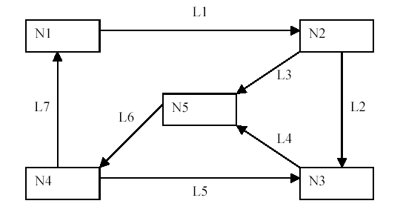

Bonus for high mark: Write the momentum equations for the thermal-hydraulic system above and show it in matrix form.

